Parth Babbar

Individual retirment account

**Introduction:**

Individual Retirement Accounts (IRAs) are tax-advantaged savings accounts established under the Employee Retirement Income Security Act (ERISA) of 1974 to help individuals save for retirement. These accounts have become a cornerstone of Americans' retirement plans. Contributions to IRAs can grow tax-deferred or tax-free, depending on the kind of IRA selected by the account owner.

**Types of IRAs:**

1. **Traditional IRA:** Contributions to Individual Retirement Accounts (IRAs) may be tax deductible, depending on income and membership in employer-sponsored retirement plans. Earnings in IRAs grow tax-deferred until they are withdrawn and taxed as ordinary income. Early withdrawals before age 59½ may result in a 10% penalty in addition to usual income taxes, unless certain conditions apply. These features make IRAs attractive for retirement savings, but they need strict adherence to withdrawal requirements to avoid penalties.
2. **Roth IRA:** Contributions to Roth Individual Retirement Accounts (IRAs) are made after taxes and hence are not tax deductible. Roth IRAs offer tax-free gains and qualifying withdrawals after age 59½ and a 5-year holding period. Roth IRAs provide a flexible retirement savings option since contributions (but not earnings) can be withdrawn penalty-free at any time.
3. **SEP IRA:** SEP IRAs are designed specifically for self-employed individuals and small company owners, with larger contribution limits than traditional IRAs. Contributions are tax deductible, and gains accumulate tax-deferred until withdrawn, giving significant tax benefits for retirement savings.
4. **SIMPLE IRA:** The Simple IRA is designed for small enterprises with fewer than 100 workers and allows both employers and employees to contribute. Contributions are tax-deductible, and gains grow tax-deferred until withdrawn, making it an attractive retirement savings option for qualified organisations and workers.

**How IRAs Work:**

1. **Contribution Limits:** For Traditional and Roth IRAs, the annual contribution maximum is $6,500 for individuals under 50 and $7,500 for those over 50. SEP IRAs enable contributions of up to 25% of pay, or $66,000 per year, whichever is less. SIMPLE IRAs have yearly restrictions of $15,500 for anyone under 50 and $19,000 for those 50 and over. These restrictions provide for flexibility based on age and kind of retirement plan, enabling a variety of savings goals.
2. **Tax Advantages:** It varies depending on the type of growth.
3. **Withdrawal Rules:** Penalties apply for early withdrawals (before age 59½), except under certain conditions.

**Benefits & Drawbacks:**

**Benefits:**

1. **Tax Advantages:** IRAs offer significant tax benefits, such as tax-deferred or tax-free growth of earnings, depending on the type of IRA.
2. **Flexibility:** IRA contributions can be invested in a wide range of assets, providing flexibility and control over retirement savings.
3. **Portability:** IRAs can be moved or rolled over into multiple IRA accounts or other retirement plans without tax penalties.

**Drawbacks:**

1. **Contribution limits:** Limit the amount you may save annually.
2. **Early withdrawal penalties:** Early withdrawals incur a 10% penalty plus taxes.
3. **Required minimum distributions (RMDs):** Traditional IRAs are subject to mandatory withdrawals beginning at age 73.

**Statistics:**

1. **Contribution:** The annual contribution limit for 2023 is $6,500, or $7,500 if you're age 50 or older (2019, 2020, 2021, and 2022 is $6,000, or $7,000 if you're age 50 or older).
2. **Growth:** 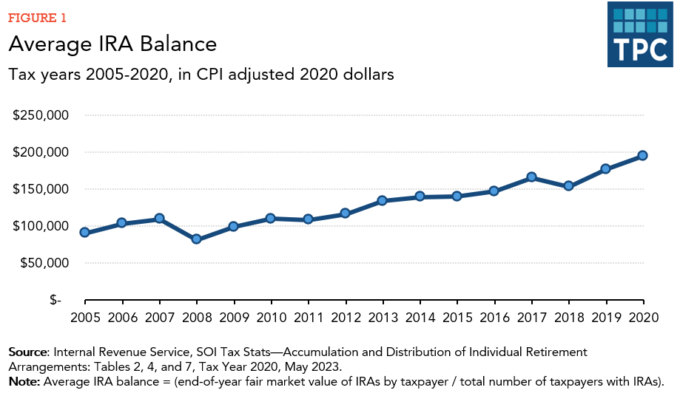

**Conclusion:**

Individual Retirement Accounts (IRAs) are essential for retirement planning in the United States, as they provide tax breaks and flexibility. Understanding the many types of IRAs, including their features and contribution restrictions, is critical for making educated retirement savings selections. Official IRS publications or financial consultants that specialise in retirement planning can provide the most up-to-date data and extensive information.